● Recognize different ports and cables of your lab system and write the different ports and cables in word and attach photos.
Ports:
1. USB (Universal Serial Bus) Port*: A rectangular port used to connect devices such as flash drives, keyboards, and mice.
2. Ethernet Port : A square port used to connect to a network using an Ethernet cable.
3. VGA (Video Graphics Array) Port: A trapezoid-shaped port used to connect a monitor or projector using a VGA cable.
4. HDMI (High-Definition Multimedia Interface) Port: A rectangular port used to connect a monitor, projector, or TV using an HDMI cable.
5. Audio Jack: A circular port used to connect headphones or speakers.
6. PS/2 Port: A circular port used to connect older keyboards and mice.
7. Serial Port: A rectangular port used to connect devices such as modems and printers.
8. Parallel Port: A rectangular port used to connect devices such as printers.
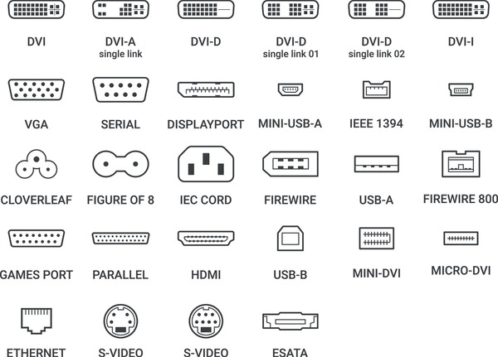
Cables:
1. USB Cable: A cable used to connect devices to a USB port.
2. Ethernet Cable: A cable used to connect devices to a network using an Ethernet port.
3. VGA Cable: A cable used to connect a monitor or projector to a VGA port.
4. HDMI Cable: A cable used to connect a monitor, projector, or TV to an HDMI port.
5. Audio Cable: A cable used to connect headphones or speakers to an audio jack.
6. PS/2 Cable: A cable used to connect older keyboards and mice to a PS/2 port.
7. Serial Cable: A cable used to connect devices to a serial port.
8. Parallel Cable: A cable used to connect devices to a parallel port.
9. Power Cord: A cable used to connect devices to a power source.
10. IDE (Integrated Drive Electronics) Cable: A cable used to connect older hard drives and CD/DVD drives to a motherboard.
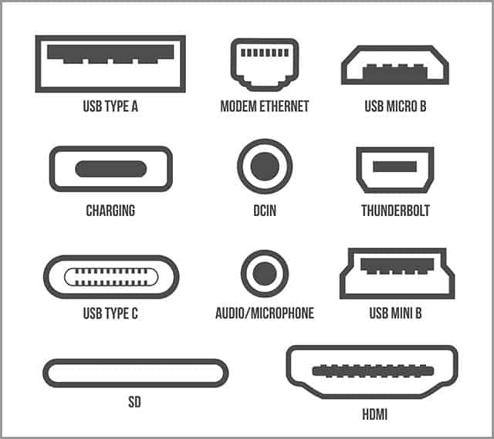
11. SATA (Serial Advanced Technology Attachment) Cable: A cable used to connect newer hard drives and solid-state drives to a motherboard.

